**Random Walker segmentation**

**(1) open one image on histogram filter :**

from skimage import io , img_as_float

import matplotlib.pyplot as plt

import numpy as np

img = img_as_float(io.imread("C:/Users/abc/Desktop/image/random walker.jpg"))

plt.hist(img.flat, bins=100, range=(0,1))

→ Output :

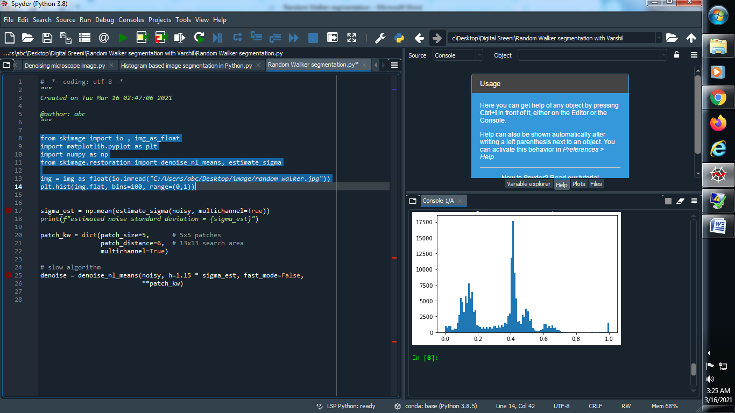

**(2) Now open this image using non-local filter of denoise image :**

from skimage import io , img_as_float

import matplotlib.pyplot as plt

import numpy as np

from skimage.restoration import denoise_nl_means, estimate_sigma

img = img_as_float(io.imread("C:/Users/abc/Desktop/image/random walker.jpg"))

sigma_est = np.mean(estimate_sigma(img, multichannel=True))

print(f"estimated noise standard deviation = {sigma_est}")

patch_kw = dict(patch_size=5, patch_distance=6, multichannel=True)

denoise_img = denoise_nl_means(img, h=1.15 * sigma_est, fast_mode=True,

**patch_kw)

plt.hist(denoise_img.flat, bins=100, range=(0,1))

→ Output :

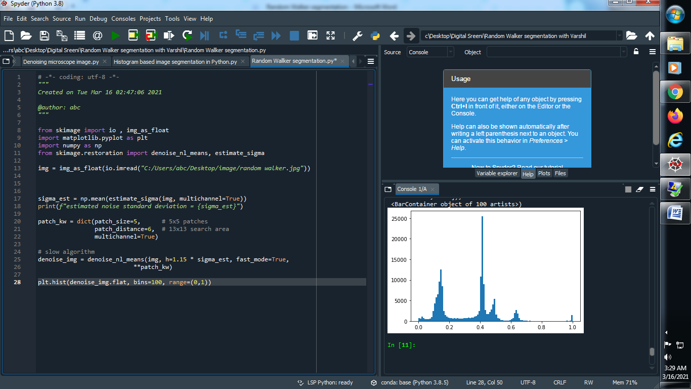

**(3) Equal Filter of histogram :**

from skimage import io , img_as_float

import matplotlib.pyplot as plt

import numpy as np

from skimage.restoration import denoise_nl_means, estimate_sigma

img = img_as_float(io.imread("C:/Users/abc/Desktop/image/random walker.jpg"))

sigma_est = np.mean(estimate_sigma(img, multichannel=True))

print(f"estimated noise standard deviation = {sigma_est}")

patch_kw = dict(patch_size=5, patch_distance=6, multichannel=True)

denoise_img = denoise_nl_means(img, h=1.15 * sigma_est, fast_mode=True,

**patch_kw)

from skimage import exposure

eq_img = exposure.equalize_adapthist(denoise_img)

plt.hist(denoise_img.flat, bins=100, range=(0,1))

→ Output :

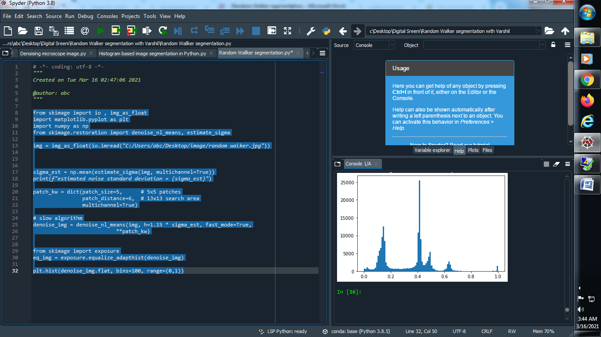

(4) show the image :

from skimage import io , img_as_float

import matplotlib.pyplot as plt

import numpy as np

from skimage.restoration import denoise_nl_means, estimate_sigma

img = img_as_float(io.imread("C:/Users/abc/Desktop/image/random walker.jpg"))

sigma_est = np.mean(estimate_sigma(img, multichannel=True))

print(f"estimated noise standard deviation = {sigma_est}")

patch_kw = dict(patch_size=5,

patch_distance=6,

multichannel=True)

denoise_img = denoise_nl_means(img, h=1.15 * sigma_est, fast_mode=True,

**patch_kw)

from skimage import exposure

eq_img = exposure.equalize_adapthist(denoise_img)

plt.imshow(eq_img,cmap='gray')

→ Output :

**Simple image : Gray image :**

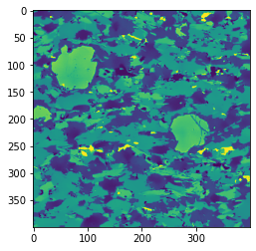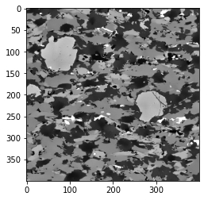

**(5) Markers in images :**

from skimage import io , img_as_float

import matplotlib.pyplot as plt

import numpy as np

from skimage.restoration import denoise_nl_means, estimate_sigma

img = img_as_float(io.imread("C:/Users/abc/Desktop/image/random walker.jpg"))

sigma_est = np.mean(estimate_sigma(img, multichannel=True))

print(f"estimated noise standard deviation = {sigma_est}")

patch_kw = dict(patch_size=5, # 5x5 patches

patch_distance=6, # 13x13 search area

multichannel=True)

denoise_img = denoise_nl_means(img, h=1.15 * sigma_est, fast_mode=True,

**patch_kw)

from skimage import exposure

eq_img = exposure.equalize_adapthist(denoise_img)

plt.imshow(eq_img,cmap='gray')

#plt.hist(denoise_img.flat, bins=100, range=(0,1))

**markers = np.zeros(img.shape,dtype=np.uint)**

**markers[(eq_img < 0.6) & (eq_img > 0.3)] = 1**

**markers[(eq_img > 0.8) & (eq_img < 0.99)] = 2**

**plt.imshow(markers)**

→ Output :

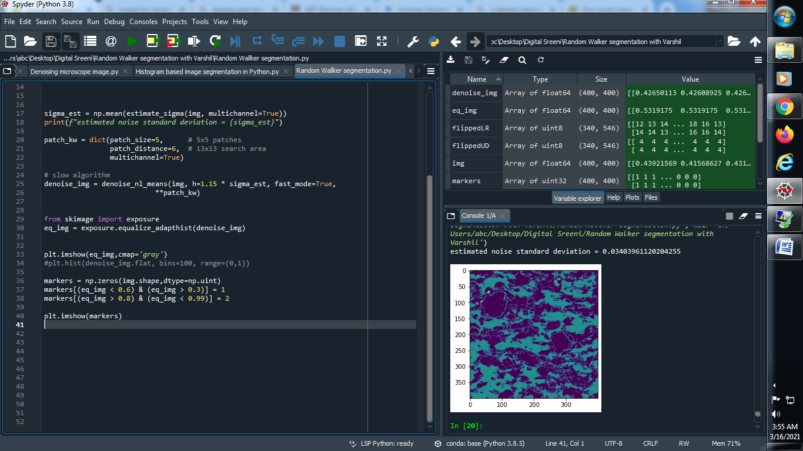

**(6) Random walker image :**

from skimage.segmentation import random_walker

labels = random_walker(eq_img,markers,beta=10,mode='bf')

plt.imshow(labels)

**→ Output :**

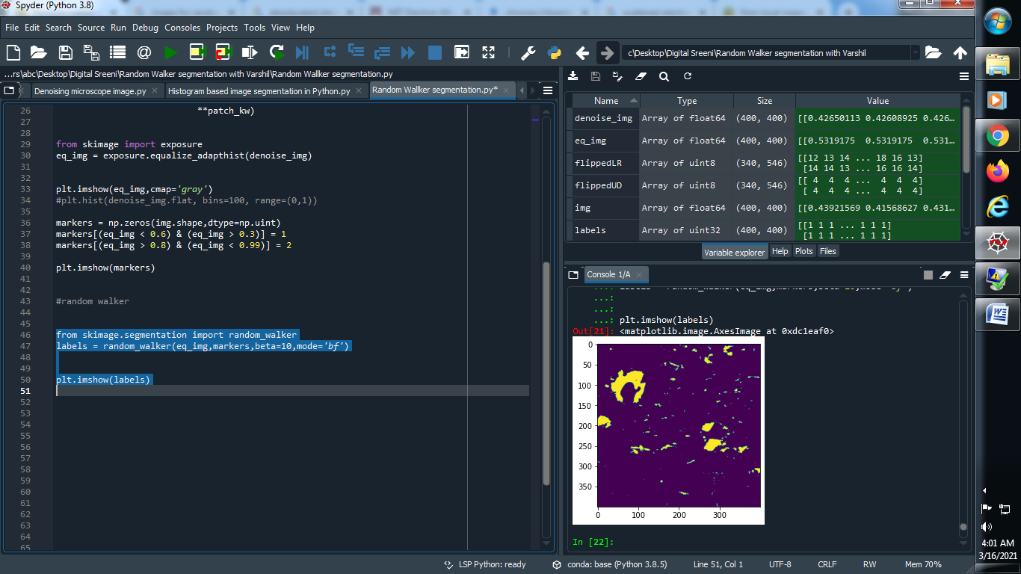

**(7) Segmentation in image :**

seg1 = (labels == 1)

seg2 = (labels == 2)

all_segments = np.zeros((eq_img.shape[0],eq_img.shape[1],3))

all_segments[seg1] = (1,0,0)

all_segments[seg2] = (0,1,0)

plt.imshow(all_segments)

→ Output :

